Non-Assessed 2FCMb Practice in Generating a Weibull Plot
You are given data (see below) for a ceramic material, determined in 3-point flexural
strength tests conducted at a strain rate of 1 x 10⁻³ s⁻¹ .

You are required to:

(i) Find out what are the sample standard deviation and coefficient of variation of a
data set are defined as, and how to calculate these parameters.

(ii) Calculate the mean flexural strength, together with the sample standard deviation
and coefficient of variation for the flexural strength data.
σ= 118.7MPa; x̄ = 301.6 MPa CV = 0.393

(iii) Draw a graph of survival probability P_{s} against flexural strength, s. Use the mean
rank P_{s} (survival probability) estimator.
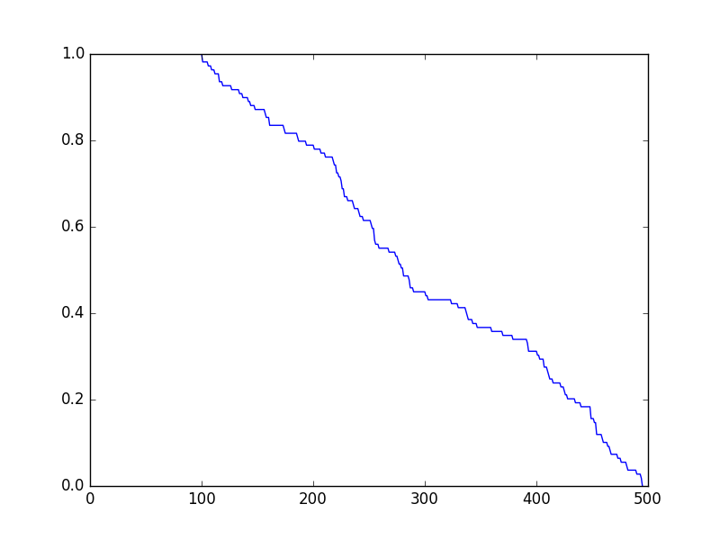

(iv) Draw the corresponding Weibull graph for the material, using the mean rank Ps
(survival probability) estimator, and tabulating all the relevant numerical data.
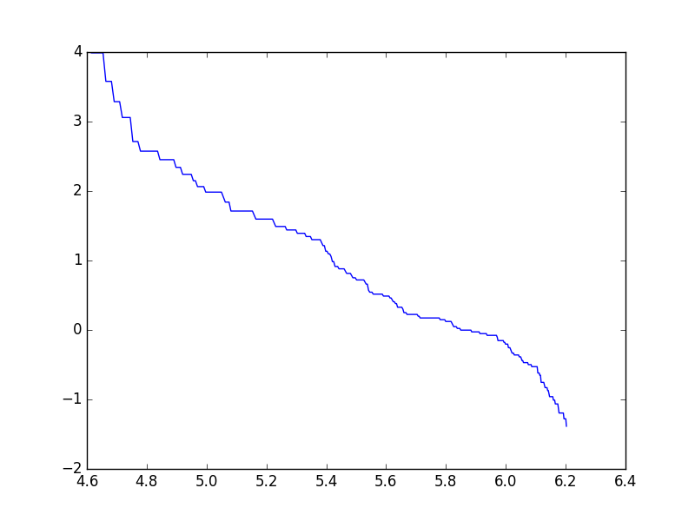
x-axis: ln(σ(MPa)); y-axis: ln(ln(Ps))

(v) Using the data from (iv), determine the Weibull modulus, m value for the materialx
graphically using least-squares linear regression method to generate the “best-fit”
trend-line, giving the regression equation and correlation coefficient R.
-m = -2.6; Weibull’s modulus = 2.6.
LinregressResult(
slope=-2.6002329759682414,
intercept=15.172276977982271,
rvalue=-0.9871316609133981,
pvalue=3.3841323908584169e-314,
stderr=0.021274958238095085)

Given the number of data, it is recommended that while you check your calculations
manually, you use a spreadsheet program such as Excel to tabulate the data, do the
calculations, and plot the graphs.

The 3-Point Flexural Strength Data for a Ceramic (MPa) is omitted from here.

